**Patient Liaison Group Newsletter - November 2024**

**Surgery Updates**

We are very proud that our accreditation as a Purple Star surgery is now extended to September 2027.

This acknowledges our service to adults with learning disabilities across Hertfordshire, Well done to Mia for her hard work on this project.

We now have new signage for our main entrance A and smaller entrance B at the King George site. Remember that Blood Tests, MSK Practitioner and Social Prescriber appointments are upstairs via entrance B.

**Staff Updates**

We will be saying goodbye to our lovely medical secretary Jo who leaves us after many years of diligent service.

**Website**

We are now operating a fast registration service which enable you to register with the practice within 48 hours for most applications!

**Training Days**

The Surgery will be closed for training from 1pm on the following dates:

06/11/2024 Wednesday

09/01/2025 Thursday

**Appointment Cancellations: Did Not Attend!**

During August and September 484 patients have not attended for their appointments

If you are unable to make your appointment, then please can you call the Surgery and cancel it so that another patient can use it

**Patient Information From Other Healthcare Organisations**

As GP Surgeries do not use the same clinical system as the Hospital or NHS 111, details of patient consultations with organisations such as these will not be visible on your NHS app and the Surgery immediately. It is dependent on how quickly the information is sent to us which is then uploaded through our system.

**Hertfordshire and West Essex Integrated Care System**

**Change NHS: Helping shape a health service fit for the future**

NHS staff are working harder than ever to get services back on track, to get waiting lists down and consistently deliver the best care.

We know change is needed. But we also know that many of the solutions we need are already here, working somewhere in the NHS today.

Whether you have a little to say or a lot, your views, experiences and ideas will shape immediate steps and long-term changes: a new 10-Year Health Plan for the NHS.

**This is a once in a generation opportunity to make the NHS fit for the future. Together we can fix it. We need your voice. Go to** [**change.nhs.uk**](http://change.nhs.uk/) **to find out how you can take part.**

**Cancelling Your Appointment**

If you are unable to attend an appointment, please remember to let the Surgery know

You can do this by either calling the Surgery, press Option 2, then Option 1 and follow the instructions given or via the NHS App

**Reminder Text**

The Surgery sends reminder text messages to patients that have an appointment booked in advance. This text also contains a link to cancel should be unable to attend.

If you have opted out of the text messages from the Surgery then you will not receive this message.

**November is Prostate Cancer Awareness** month and the Stevenage South PCN PPG have organised a Patient Information Evening on the subject. The event will take place on Thursday 21st November commencing at 19.30 at the Arts & Leisure Community Centre, Roaring Meg, Stevenage.

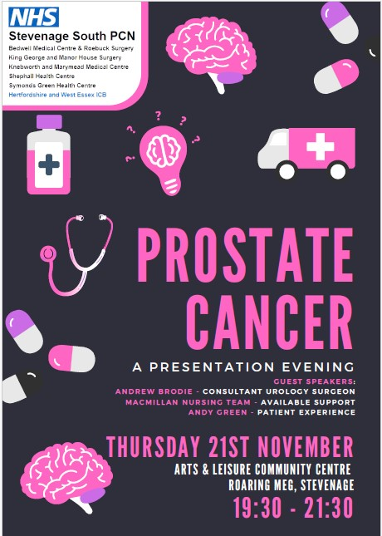

**Hertfordshire Health Walks**

Please find below a poster for the first taster walk which is taking place on 10 October starting and ending at the Library, Town Centre. Stevenage SG1 1HD.  Opportunity for a free cup of tea at the end of the walk which last about 30 minutes

