**Patient Liaison Group Newsletter - August 2024**

**Patient Information From Other Healthcare Organisations**

As GP Surgeries do not use the same clinical system as the Hospital or NHS 111, details of patient consultations with organisations such as these will not be visible on your NHS app and the Surgery immediately. It is dependent on how quickly the information is sent to us which is then uploaded through our system.

**Surgery Updates**

**Staff Updates**

Our trainee GP’s will be moving on to continue their studies and a new intake arrives in early August. There are 8 new GP trainees or students in total!

Congratulations to our Health care Assistant Tilly who welcomed her new baby to the world in July!

Welcome to HCA Catherine Pearce who joins us in August both as an HCA and maternity cover

**Website**

The new website will go live in late July. Clearer, tidier and more easy to navigate, please take a look.

**Training Days**

The Surgery will be closed for training from 1pm on the following dates:

05/09/2024 Thursday

08/10/2024 Tuesday

06/11/2024 Wednesday

09/01/2025 Thursday

04/02/2025 Tuesday

05/03/2025 Wednesday

**Appointment Cancellations: Did Not Attend!**

Since April, 900 patients have not attended for their appointments

If you are unable to make your appointment, then please can you remember to call the Surgery and cancel it so that another patient can use it

**Healthcare Passports**

The Healthcare Passport for children and young people with a learning disability and/or complex needs is now available to download. The passport was created to ensure a more equitable experience when visiting healthcare settings. The passport is a co-production between the East and North Herts NHS trust, specifically Roald Dahl Children's Medical Complexity Nurse Specialist, Eleanor Willis, and parent carer, Sarah Leigh.

The passport is an individualised document that communicates a child’s physical, emotional and communication needs, and any access requirements that they may have, to ensure appointments and/or admissions are as easy as possible for a child/young person and their families.

The passport is a child/family-held record and contains information in a traffic light system - Red being ‘Things you must know about me’, Amber ‘Things that are important to me’, and Green ‘My likes and dislikes’. Information such as normal observations, diagnoses, medication and how best to administer it, reasonable adjustments/access requirements, routines and professional contacts, can all be included within the passport.

Parent carer, Sarah Leigh, says, “I joined the co-production of the Healthcare Passport as we often find hospital and GP appointments inaccessible for my son. I wanted to have a document that would contain necessary information that could potentially create a smoother, quicker and more equitable experience for us.”

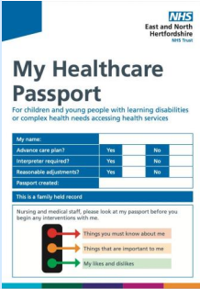

**Cancelling Your Appointment**

If you are unable to attend an appointment, please remember to let the Surgery know

You can do this by either calling the Surgery, press Option 2, then Option 1 and follow the instructions given or via the NHS App

The passport can be downloaded here:

[My-Healthcare-Passport-July-2024.pdf (enherts-tr.nhs.uk)](https://www.enherts-tr.nhs.uk/wp-content/uploads/2024/07/My-Healthcare-Passport-July-2024.pdf)

A featured video on the Healthcare Passports, as part of the trust’s AGM ‘patient story’ can be found here: <https://www.youtube.com/watch?v=-1m-bhnqPHA>

**Reminder Text**

The Surgery sends reminder text messages to patients that have an appointment booked in advance. This text also contains a link to cancel should be unable to attend.

If you have opted out of the text messages from the Surgery then you will not receive this message.

**Bereavement Support Group**

Lisa Mardle (Personalised Care Lead – Stevenage South PCN) has announced that she is starting a Bereavement Support Group for the residents of Stevenage and surrounding villages. She is excited to say that her first session will be held on Saturday 3rd August.

She is working in collaboration with the Healthy hub who have secured funding for the next 2 years. These sessions will be held on the first Saturday of every month at the Healthy Hub. She will have an experienced bereavement support worker working alongside her to provide the support needed to those who are coping with loss and grief.

I have attached the information flyer, feel free to share far and wide!

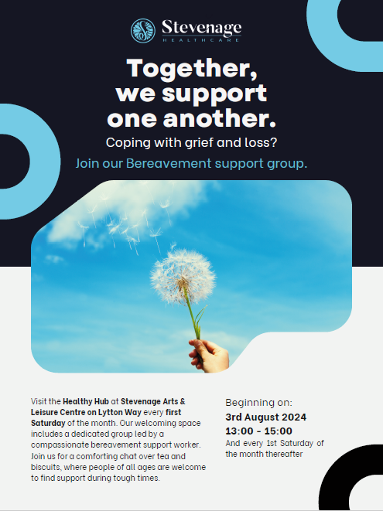

**Menopause Support Group**

* The Menopause Support Group is held within the Healthy Hub once a month. It is hosted by Juanita Prescott.
* Women are invited to attend to learn more about the stages of menopause and the symptoms that they bring, why they are experiencing them, how lifestyle changes can improve them, the importance of good nutrition, physical activity, sleep, and mental health support. The sessions provide women the opportunity to discuss their concerns, share their experiences and what has helped them.
* The Healthy Hub has joined with the NHS Taking Therapies services who provide ongoing mental health support after the meeting.
* The dates for this year’s meeting are: July 27th, August 31st, September 28th, October 26th and November 23rd
* The sessions have been funded by the Stevenage Borough Council and women can attend free of charge.

