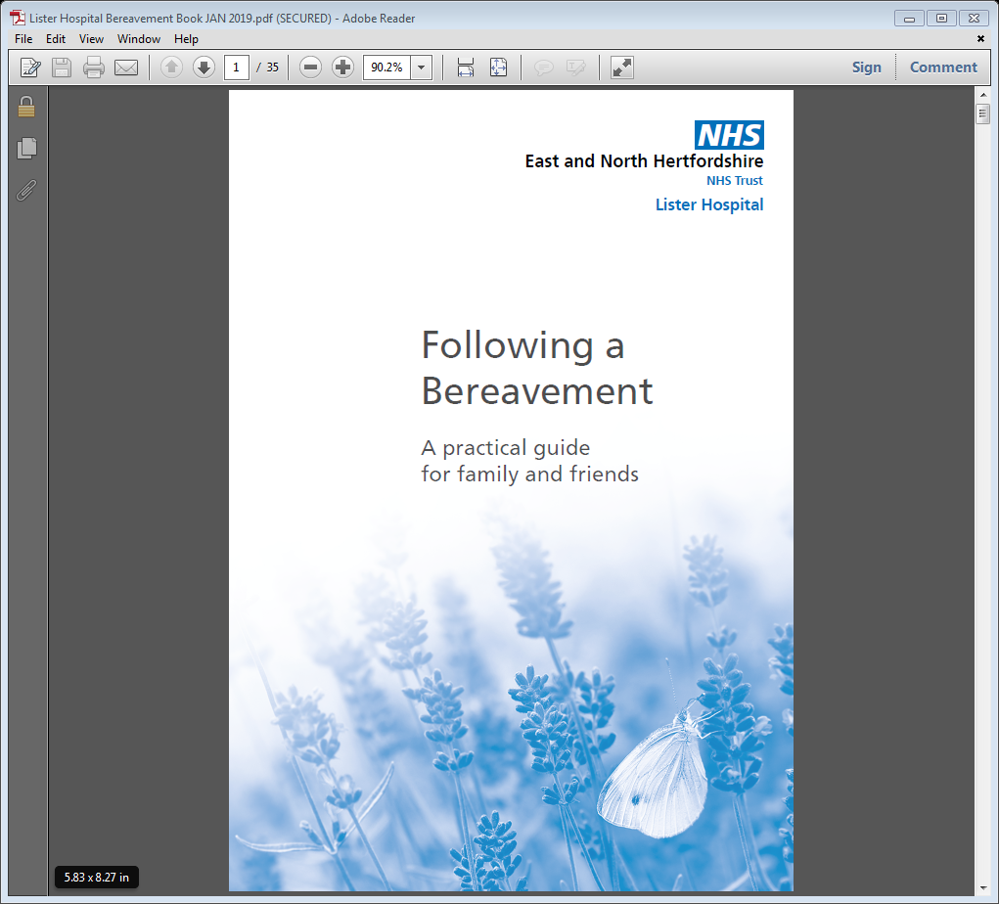

Main telephone number: 01438 284634

**Following a Bereavement**

We offer you condolences at this sad time.  This information leaflet has been produced to explain the process following the death of your relative

The Medical Examiner Service was established by the Government with the intended requirement for Medical Examiners (M.E) to provide independent scrutiny of all deaths not taken for investigation by Hertfordshire Coroner Office.

Within East and North Herts all deaths that occur will be reviewed by an M.E based at East and North Herts NHS Trust.  The M.E is an independent, senior doctor who has not been involved in the care of your relative.  Medical Examiner Officers (MEO) will also work closely with the M.E and will coordinate the entire process of ensuring the required certificate of cause of death can be issued.  You will have a named MEO who will be your main point of contact throughout the entire process.

The M.E will review the required medical notes and have a discussion with the doctor(s) responsible for the care of your relative.  This is to ensure that the information entered on the medical certificate of cause of death (MCCD) is correct and that all information relating to the death is recorded appropriately.  The M.E is NOT the same as the coroner.

Following a death, the Medical Examiner office will be notified by the attending GP.  Within the following few days, you will receive a telephone call from your designated MEO who will answer any questions you may have about the Medical Examiner process.  You will also be given the opportunity to raise any concerns you have regarding your relative’s care during their final illness.

If the M.E and responsible doctor agree with the cause of death of your relative, the MEO will facilitate for the responsible doctor to complete the medical certificate of cause of death.  The certificate will then be emailed by the GP surgery directly to Hertfordshire Registration Service.

Your designated MEO will contact you to inform you of the cause of death recorded and to confirm that you are able to make an appointment with the Hertfordshire Registration Service on 0300 1234045 to register your relative’s death.

If the M.E and responsible doctor feel there is a requirement for the coroner to be involved, the Medical Examiner office will send a referral to the coroner once your designated MEO has contacted you to update you.  A referral to the coroner does not necessarily mean a post mortem will be required, however your designated MEO will explain the reasons why the coroner needs to be notified.

Once a referral has been made to the coroner, a coroner’s officer will keep you informed throughout the process of their involvement. Hertfordshire Coroners Service can be contacted on 01707 292707.

We do understand that you may not be ready to receive our call so soon after the death of your relative, please let us know if you would like us to contact you another day.

For further support and advice, we have a Bereavement Assistant who will be able to help you.